3. SOFTWARE PEER REVIEWS & INSPECTIONS
Module Name: Review & Inspection
Test Case ID: bms_id_03
Tester Name: Vaishnavi Thakor
Webpage URL: https://in.bookmyshow.com
Scenario ID: 1a
Introduction & Purpose
This document presents a complete analysis of the BookMyShow movie and ticket-booking workflow from the perspective of a Software Tester. The review covers requirements and quality considerations for city selection, movie search, movie details, cinema and showtime selection, seat selection, booking, offers, payment, confirmation and booking history.
The goal is to understand how formal requirement reviews, walkthroughs, peer reviews and inspections can be applied to a real-world booking application, including their differences, roles, process steps, benefits and the critical value of identifying defects early, especially at the requirements stage.
Screenshots:
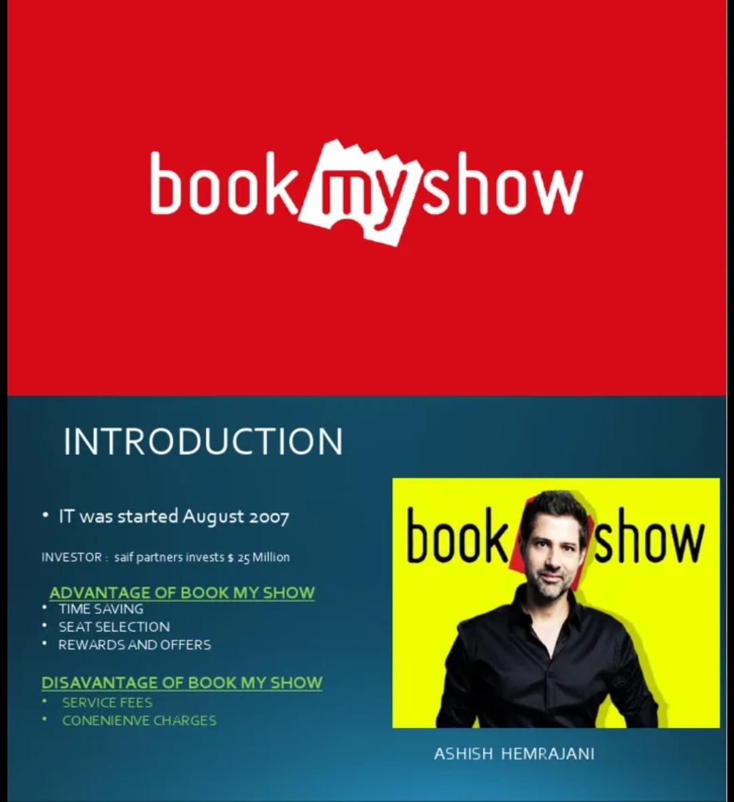
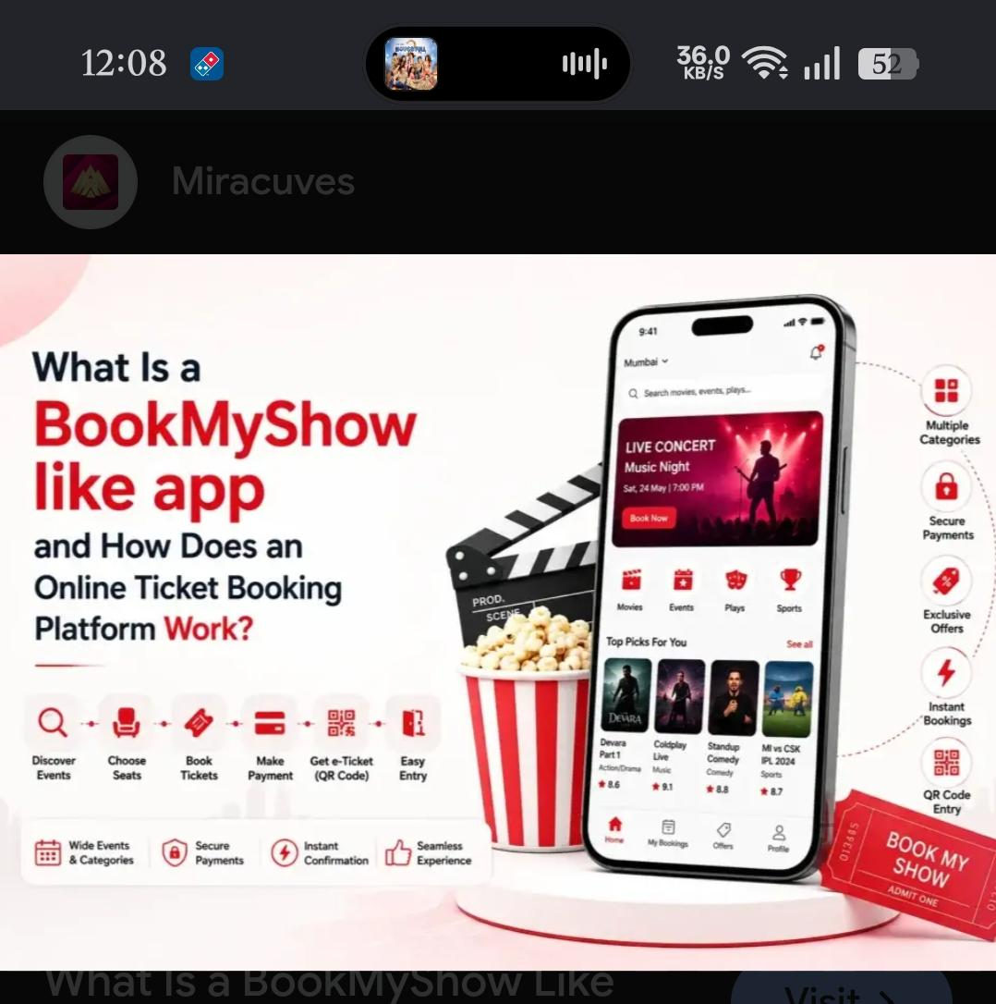
Scenario ID: 2b
Main Requirement Statement
The main requirement areas reviewed for the BookMyShow workflow are:
• The user shall be able to select a city and view relevant movie/cinema information.
• The user shall be able to search for an available movie.
• The user shall be able to select a movie, date, cinema and available showtime.
• The user shall be able to select available seats and view an accurate booking summary.
• The system shall validate booking, offer/coupon and payment conditions and provide confirmation after successful booking.
Tester Note: These statements are written as testable requirements. Each can be traced to functional test cases and reviewed for clarity, completeness and consistency.
Screenshots:
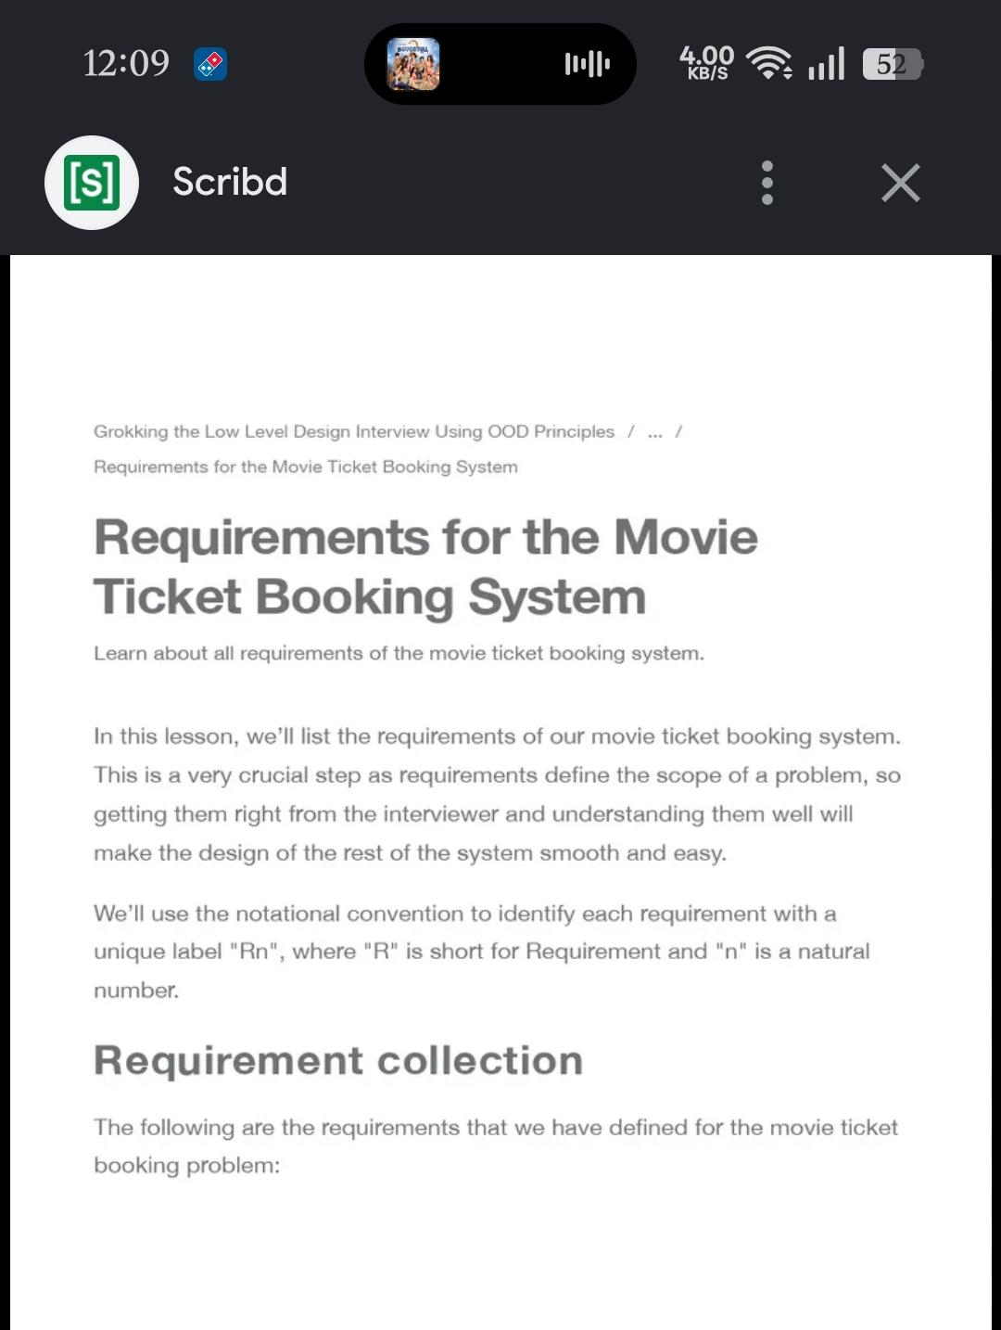

Scenario ID: 3c
Notes & Best Practice Reference
BookMyShow requirements should be reviewed before implementation and before major changes to the booking workflow. A structured peer review or inspection is useful for identifying ambiguous requirements such as seat availability, payment failure handling, cancellation rules, duplicate booking prevention and confirmation behavior.
Best practice is to keep the review focused on technical quality, use a checklist, involve reviewers with different viewpoints and record defects and action items.
Screenshots:
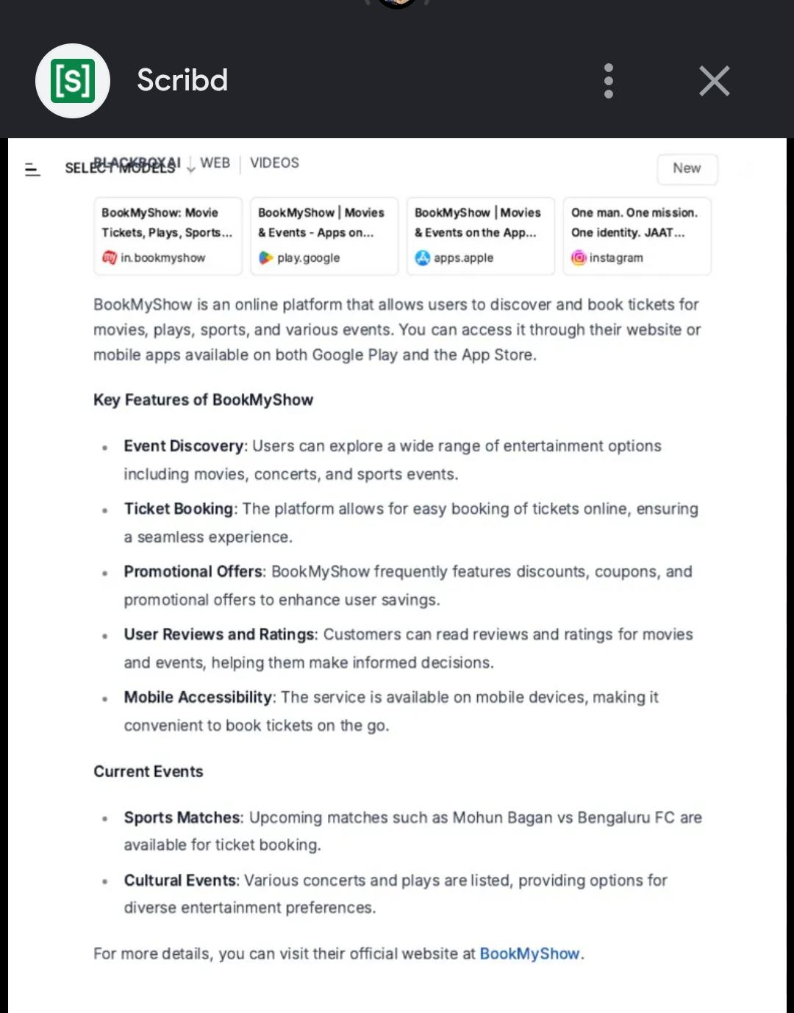
Scenario ID: 4d
Benefits Table
Key benefits identified for reviewing the BookMyShow workflow:
• Useful for requirements, booking rules, UI flows and test procedures
• Simple and structured way to identify ambiguity
• Knowledge sharing among developers, testers and stakeholders
• Brings different stakeholder viewpoints into the review
• Enables early defect detection before implementation
• Provides an organized approach to detect, evaluate and track defect solutions
• Improves testability and reduces rework later in the development life cycle

Scenario ID: 5e
Software Classification Matrix
For this academic practical, the BookMyShow workflow can be reviewed across the following artifact areas:
Requirements – City selection, movie search, showtime, seat and booking rules
Plans – Test plan, review plan and release/booking validation activities
Design – Navigation, seat-layout and booking-flow design
Code – Validation and booking-related implementation
Test Procedures – Functional, UI, negative and payment-related test cases
The review should ensure that each artifact has sufficient requirements coverage and that important user and business rules can be traced to tests.
Screenshots:
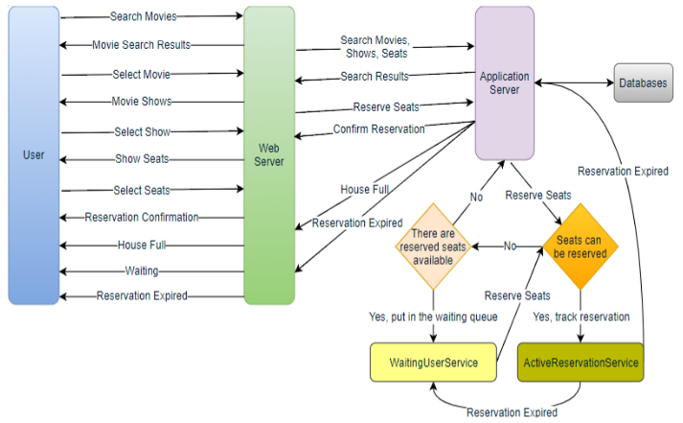
Scenario ID: 6f
Roles Table
Defined roles for a BookMyShow requirements inspection:
• Moderator – Conducts and controls the inspection.
• Author – Producer of the requirements/workflow document and answers technical questions.
• Reader – Presents or reads/paraphrases the requirement to the team.
• Recorder – Documents defects, open issues and action items.
• Inspectors – Examine the requirements and identify defects.
Critical rule: The Author should not be the Reader, Recorder or Moderator. The Moderator should be independent of the authoring role so that the inspection remains objective.

Scenario ID: 7g
Inspection Process Steps
The formal process applied to the BookMyShow requirements consists of:
1. Planning – Organize the requirements package, checklist, participants and schedule.
2. Overview – Give the team a high-level understanding of the booking workflow.
3. Preparation – Each inspector independently searches for defects and raises questions.
4. Inspection Meeting – The team classifies and records defects and issues.
5. Third Hour – Optional informal resolution of open issues.
6. Rework – The Author corrects major requirement defects.
7. Follow-up – The Moderator verifies corrections and closure.
This process helps prevent casual discussion from replacing systematic defect detection.

Scenario ID: 8h
Best Practices List
Process best practices for BookMyShow review:
• Keep the review focused on technical quality and testability.
• Keep the process simple and structured.
• Minimize unnecessary presentations.
• Use a round-table review format.
• Use checklists and readiness/completion criteria.
• Capture action items, defects and review metrics.
Team best practices:
• Use at least three inspectors where practical.
• Include diverse viewpoints such as tester, developer and business/user perspective.
• Keep the Author out of Moderator/Reader/Recorder roles.
• Use a trained and independent Moderator.
• Avoid management participation when it could reduce objective defect reporting.

Scenario ID: 9i
Rationale for Early Reviews
Early formal reviews have high value for the BookMyShow workflow because requirements defects can become expensive implementation and testing defects later.
Examples include unclear seat-locking rules, incomplete payment-failure behavior, missing cancellation conditions, ambiguous showtime availability and incomplete booking-confirmation requirements. Finding these issues while requirements are still being defined is easier than correcting them after design, coding and deployment.
Tester Conclusion: Requirement inspection should be performed before design and coding for the booking workflow because early defect detection improves communication, reduces rework and makes test cases more complete.
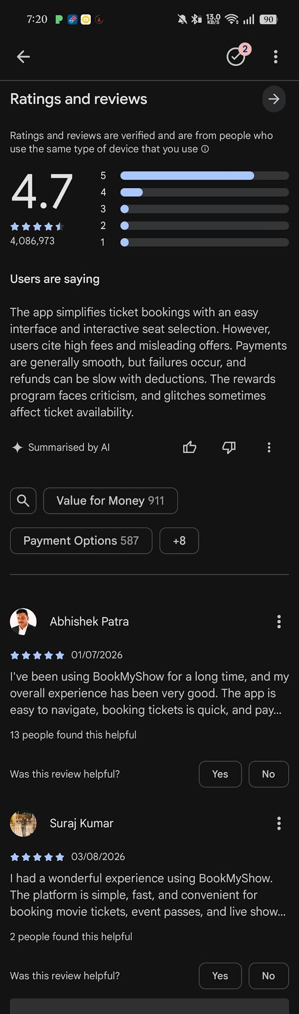

Scenario ID: 10j
Walkthrough vs Formal Inspection – Comparison
Aspect | Walkthrough | Formal Inspection / Peer Review
Formality | Informal | Formal, process-driven
Leadership | Usually the author | Moderator (not the author)
Preparation | Light / optional | Mandatory individual preparation
Roles | Flexible | Defined (Moderator, Reader, Recorder, Inspectors)
Goal emphasis | Understanding + defects | Defect detection + process metrics
Checklist | Optional | Strongly recommended
Output | Notes / action items | Formal defect log + metrics
For BookMyShow, a walkthrough can be useful for explaining the booking flow, while a formal inspection is more appropriate when the team needs systematic defect identification and traceable review results.

Scenario ID: 7g
Summary of Findings (Software Tester View)
1. BookMyShow requirements for city selection, movie search, showtime, seats, payment and confirmation should be clear and testable.
2. Five well-defined inspection roles can be used; the Author should be excluded from control roles to preserve objectivity.
3. A structured seven-step process supports preparation, focused defect detection, rework and verified follow-up.
4. Early review can identify missing booking rules before design or coding begins.
5. Best practices emphasize technical focus, checklists, diverse inspectors, defect tracking and objective review.
6. For Tutorial-3 the student should: (a) apply a requirements checklist to the BookMyShow booking requirements, (b) simulate a walkthrough and formal inspection, (c) produce a defect log, and (d) reflect on the differences and value of early reviews.

